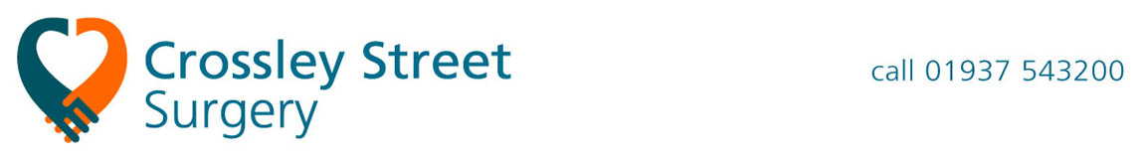
Crossley Street Surgery
Crossley Street
Wetherby
LS22 6RT

Appointments
Hospital name and address

Dear Sir / Madam,

Your full name
Your date of birth
Your NHS Number (if you know it)
Your address
Your preferred telephone number

Our mutual patient is awaiting care from you for <Write your original problem here>.

They await an appointment and / or treatment but report the following change in their condition since their referral was sent to you.

<Explain briefly what has changed since your referral>

We request that you take the following action

- Review the patient’s hospital notes alongside this letter to determine whether their care might be expedited
- Contact the patient directly to inform them the outcome of that decision, and their likely wait for further care
- File this letter and document your decision in the patient’s medical record.

Yours faithfully,
Crossley Street Surgery

